Create internal and external customer tables and load data into them. To store customer data in Hive using both managed (internal) and unmanaged (external) storage models.

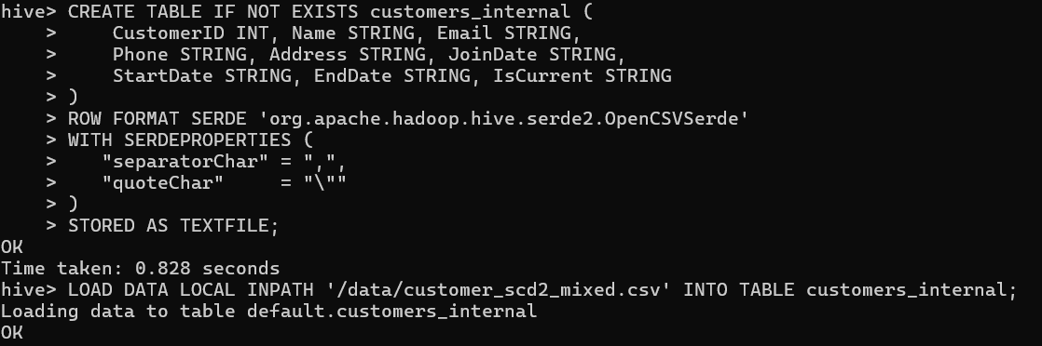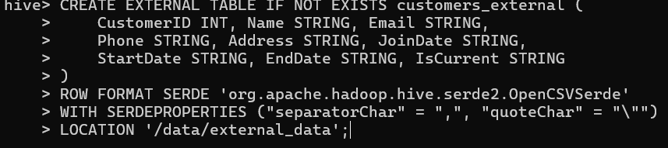
Internal Table: Hive fully manages both schema and physical data.
External Table: Hive manages metadata only, while data remains independently stored in HDFS. Through this implementation, I observed the practical architectural difference between managed and unmanaged Hive storage models in Hive.

Try to drop both external and internal tables and notice what happens to the data.
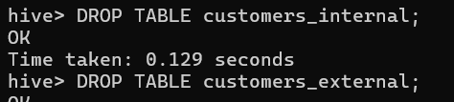
Internal table deletion removed both metadata and physical data.
External table deletion removed metadata only while preserving raw data in HDFS.

Create customer dimension (Slowly changing dimension type 2) as “customer_scd2_mixed.csv” file
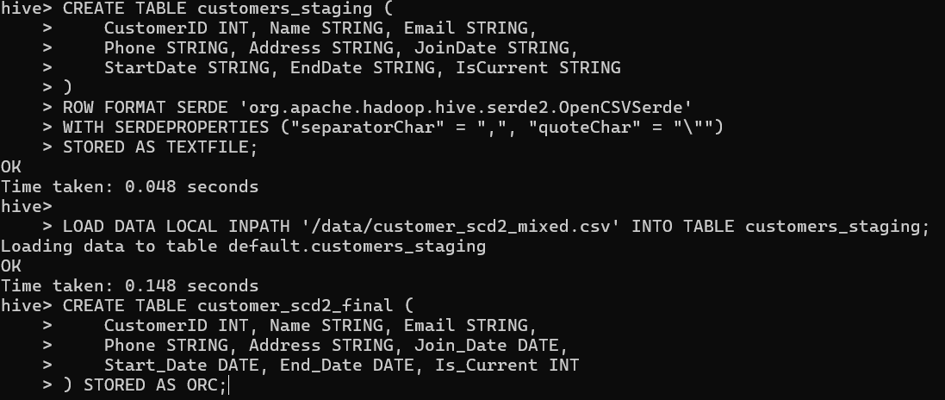

Use “customer_updated.csv” file to insert new data with end_date = null and is_current = ‘1’ and update changed data to be with end_date and is_current = “0” to track history.
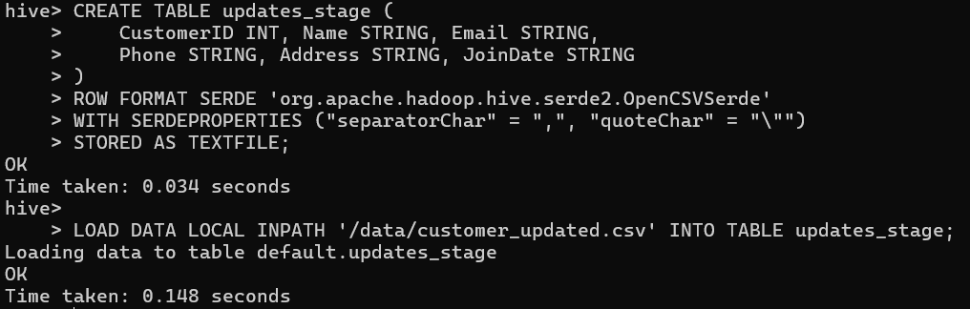

Hive doesn’t support update or deletes so find a work around to make this SCD type 2 without using Transactional tables
